**Assignment 02 Part 02  
Progress Report / Research Report**

Timothy Howard – Bachelor of Applied IT (Multi Media)  
Sean Grimson – Bachelor of Engineering Technology (Mechanical)   
Graeme Cook – Bachelor of Applied I.T. (Network Engineering)  
Nithin Sugathan – Degree Major  
Kieran Cave – Bachelor of Applied IT (Software Engineering)

**Design Factory, NZ | Wintec, NZ**

Author Note

N/A

**Project Summary** **2**

**Destination Hamilton** **4**

Destination Hamilton: - Interdisciplinary Student Collective 4

**Hamilton Central Business Association** **5**

Hamilton Central Business Association: - Industry Contacts 5

**Design Factory** **6**

Design Factory: Project Facilitators 6

**The Design Thinking Process** **7**

Empathise 7

Define 8

Ideate 8

**Secondary Research** **8**

**Primary Research** **9**

**Affinity Map** **11**

**Figure 2: Categories of Data (partially shown)** **12**

**Redefinition** **13**

Key Insights and How Might We Question 13

Signage improvements are needed to better direct traffic flow 13

Visual infrastructure improvements are needed to raise CBD perception 14

Extra security is added to the volatile areas 14

Infrastructural improvements are required to either minimize vehicle traffic flow or increase parking availability 15

Enhancing activities and entertainment in the CBD 16

Unaffordable/Expensive 17

Business Open/Close Hours 17

Loitering and Harassment 18

**Timeline for second term** **18**

**References** **20**

**Appendices** **21**

# Project Summary

# 

The interdisciplinary student collective Destination Hamilton has been requested to research and develop a solution to the following wicked problem,   
*“How to make Hamilton’s central city a desirable, destination space”.* (Reference Problem statement)

Despite Hamilton city hosting approximately 250 events in public spaces a year, possessing a growing residential market of approx 3,500 people and boasting a large workforce of approx 25,000 employees. Hamilton's CBD has been said to require a sales pitch in regards to public perception. (Reference Problem statement)

This project's wicked problem has been proposed by the Hamilton Central Business Association (HCBA) and is being conducted within the Waikato Institute of Technology’s (Wintec) Design Factory.

Destination Hamilton aims to develop a solution to the previously described wicked problem, following the design thinking process. Throughout this project the members of Destination Hamilton plan to improve and develop their future focused skills detailed within the module outline.

# Destination Hamilton

## Destination Hamilton: - *Interdisciplinary Student Collective*

Sean Grimson [Seagri17@student.wintec.ac.nz](mailto:Seagri17@student.wintec.ac.nz)  
Graeme Cook [gracoo75@student.wintec.ac.nz](mailto:gracoo75@student.wintec.ac.nz)  
Timothy Howard [timhow37@student.wintec.ac.nz](mailto:timhow37@student.wintec.ac.nz)  
Nithin Sugathan [nittho31@student.wintec.ac.nz](mailto:nittho31@student.wintec.ac.nz)  
Kieran Cave [kiecav29@student.wintec.ac.nz](mailto:kiecav29@student.wintec.ac.nz)

# 

# 

# 

# Hamilton Central Business Association

## Hamilton Central Business Association: - Industry Contacts

Vanessa Williams [vanessa.williams@hamiltoncentral.co.nz](mailto:vanessa.williams@hamiltoncentral.co.nz)  
 Vicky Redwood [vicky.redwood@hamiltoncentral.co.nz](mailto:vicky.redwood@hamiltoncentral.co.nz)  
 Mike Neale [mike.neale@hamiltoncentral.co.nz](mailto:mike.neale@hamiltoncentral.co.nz)

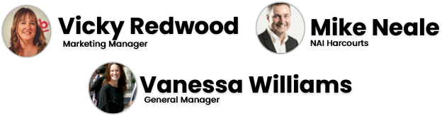

# Design Factory

## Design Factory: *Project Facilitators*

Margi Moore [margi.moore@wintec.ac.nz](mailto:margi.moore@wintec.ac.nz)  
 Elna Fourie [elna.fourie@wintec.ac.nz](mailto:elna.fourie@wintec.ac.nz)  
 Aidan Bigham [aidan.bigham@wintec.ac.nz](mailto:aidan.bigham@wintec.ac.nz)  
 Rebekah Harman [rebekah.harman@wintec.ac.nz](mailto:rebekah.harman@wintec.ac.nz)  
 Mira Cornes [mira.cornes@wintec.ac.nz](mailto:mira.cornes@wintec.ac.nz)  
 Jeremy Suisted [Jeremy.suisted@wintec.ac.nz](mailto:Jeremy.suisted@wintec.ac.nz)

# 

# The Design Thinking Process

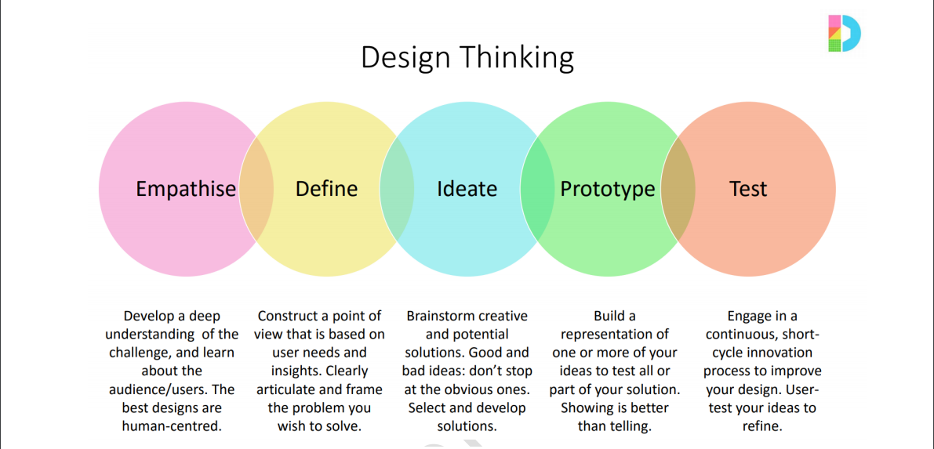

The design thinking process is referenced frequently throughout this project. The process provides the user with a project structure, which divides a given project into five well defined milestones. Those milestones are empathise, define, ideate, prototype, test and are further discussed below.

The design thinking process is exceptionally helpful when attempting to solve wicked problems which are hard to manage otherwise. The problem Destination Hamilton has been given and aims to solve is classified as a wicked problem. A wicked problem is a “problem that is difficult to clearly define, possesses interdependencies and multi-causal aspects, proposed measures have unforeseen effects, there is no clear or correct solution and there are multiple stakeholders stretching across multiple organisations” (para. 13-17).

## Empathise

The first milestone within the design thinking process is empathise. During this stage design process users must gain an empathetic understanding of the problem they aim to solve, determining the needs and desires of their target audience. The majority of information gathered within a project is gathered during this design thinking milestone. Focus is drawn to primary research during this stage with users often conducting interviews, surveys and observations. It is important during this stage to set aside your own personal assumptions and biases in order to gain a true and accurate depiction of the issue at hand to ultimately produce a solution catered towards your target audience.

## Define

The second milestone within the design thinking process is define. Design process users must now compile the data they have collected throughout the previous empathy stage. Data analyse and synthesization can then commence, comannan themes and trends must be grouped, highlighted and outlined. Digital data management tools such as Miro are often used throughout this stage to gain a greater visual understanding of the issue at hand. Following data analysis and synthesization core problems are then identified and corresponding problem statements are produced. Similar to the empathetic milestone, users must continue to conduct activities without biase to prevent the skewing of data.

## Ideate

Following the define stage the ideation process can begin. Possible problem solutions can be formed utilizing the large body of information and data that has been collected and compiled. The solutions produced should take guidance from the problem statements previously produced to ensure subject relevance. Focus is initially drawn to solution quantity during this stage. All solutions should be considered for review regardless of quality. Unlikely or outlandish solutions have the potential to become quality or effective solutions when further refined and reviewed.

## Prototype

Destination Hamilton is currently at the beginnings of the fourth stage of the design process, prototype. The aim of this milestone is to identify the best possible solution. To achieve this the top solutions proposed must be reviewed and inexpensive prototypes should be produced. Prototype analysis and review should then take place before selecting the final solution or product for further development.

## Test

The final stage of the design thinking process is testing. the chosen prototype should then be tested, analysed and evaluated. Prototype advantages and disadvantages can be outlined and utilized to modify improve the final product.

If a prototype is found to be unsatisfactory users may return to previous design thinking steps to produce new prototypes, designs to ultimately produce the best solution possible.

https://www.interaction-design.org/literature/topics/design-thinking

# 

# 

# Secondary Research

Our problem statement is, *“How might we make Hamilton's Central City a desirable destination space?”.* HCBA also gave outlined background information to the group and their desired outcomes.  
The outlined background information are as follows:

* We have events in public spaces (around 250 per year)
* A growing residential market (approx. 3,500 people)
* Big worker market (approx. 25,000) however we still need to ‘sell’ Hamilton’s CBD to the public.

# 

# 

# 

# 

# 

# 

# 

# 

# 

# 

# 

# Primary Research

While finding secondary information is an important way to find out what the current situation is in the Hamilton CBD, finding out the opinions from ourselves and the public is tremendously important for us to find a solution to the wicked problem. Secondary research was beneficial from noting what other people have discovered, however primary research is conducted by our group personally to provide more of an innovative solution with conclusive results (Types of Research, 2020).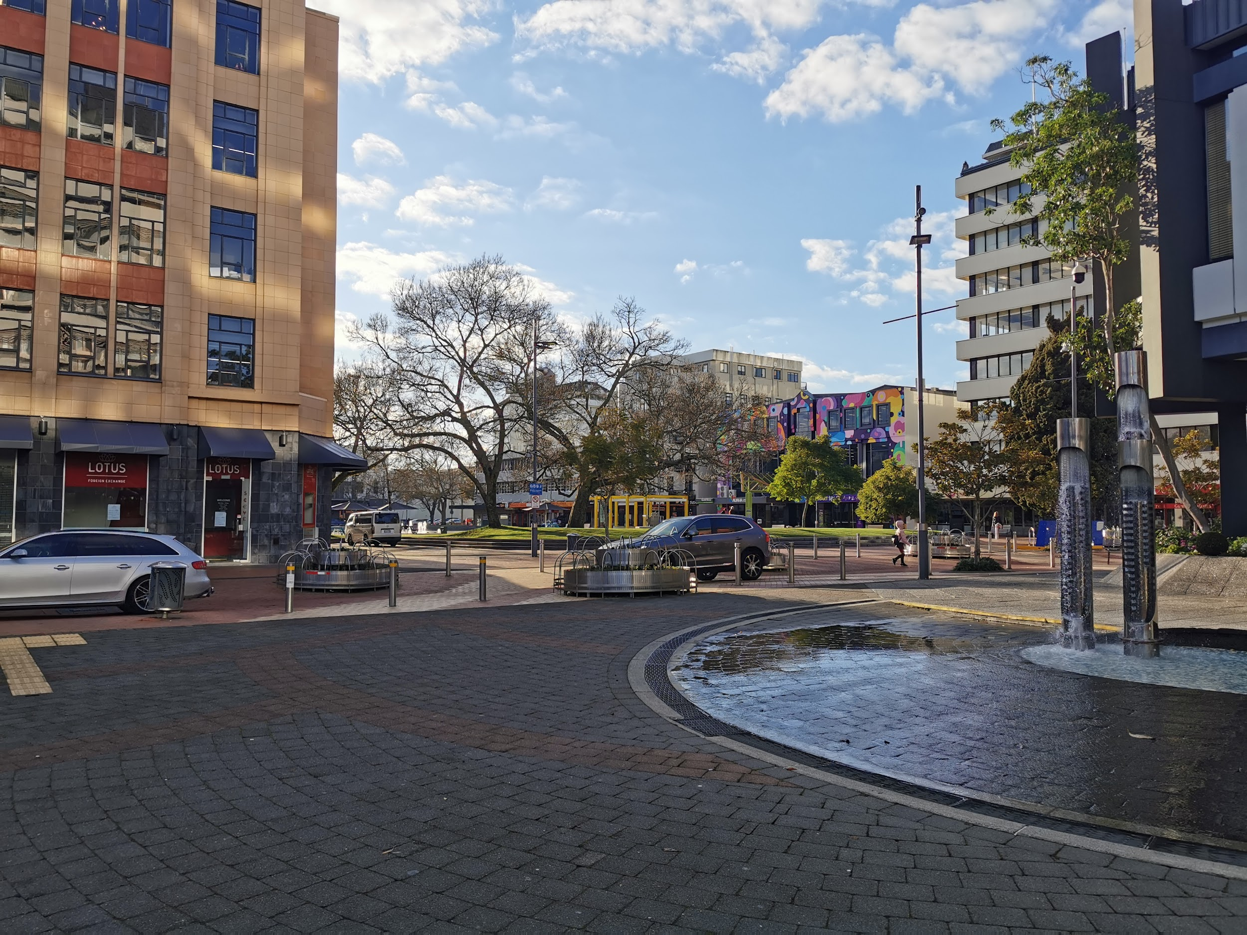

**Observations**

The first form of primary research to be conducted was personal observations of the CBD. Our purpose of this information was to discover what the current state of the CBD looked like firsthand and at different times of the day. To do this, the group walked around different locations of the CBD including Center Place, The restaurant district of the CBD, Waikato river, the bus depot etc. Notes were taken down featuring the following examples of categories: What people were doing? Where were people going? How were people interacting with the environment? What did we see in terms of environment?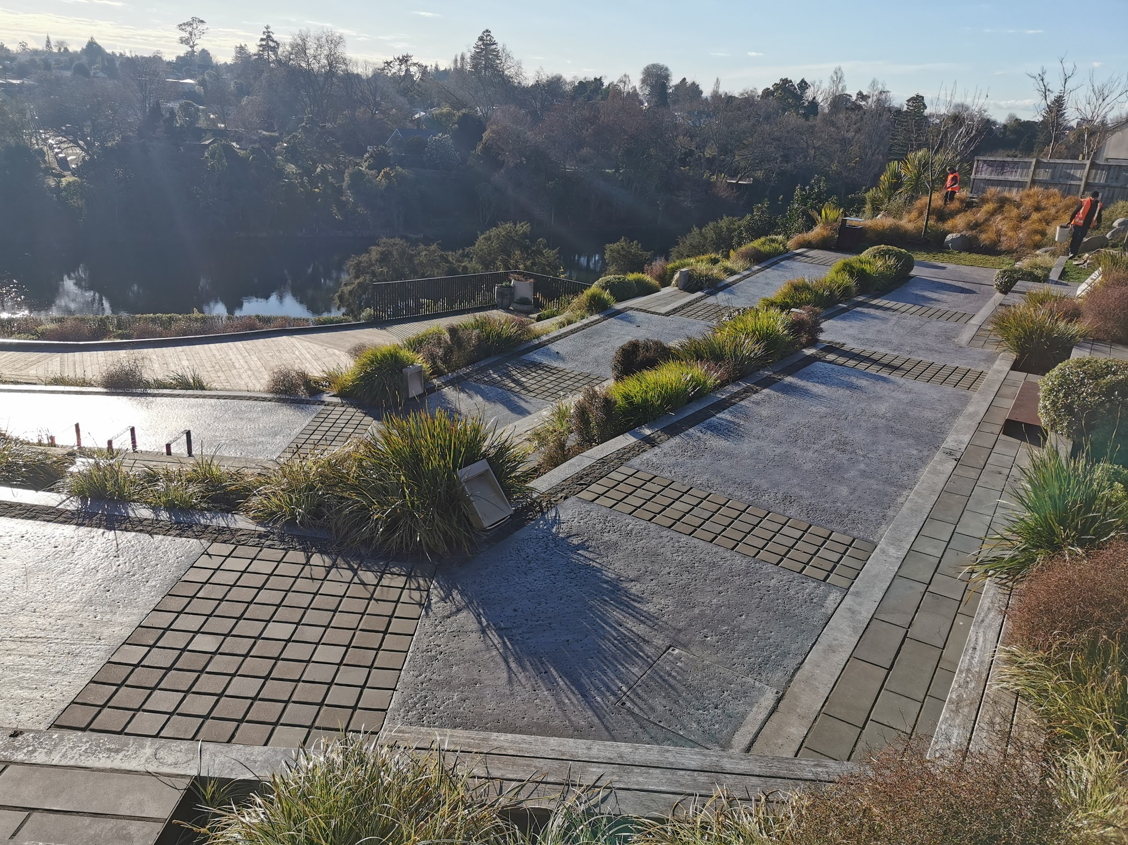

**Interviews**

Interviews were the next key primary research source of information that was to be conducted. Questions were formed in a way that would provide answers in an open manner which give us insights rather than giving us direct answers. Examples of these questions are: What are a few things that you communally dislike or like about the CBD? How would you describe in a few works or emotions your experiences in the CBD?

For a successful result from these interviews, we needed to gain information from participants that are appropriate to answer our wicked question correctly. For this reason, we decided to interview our industry partner directly; Hamilton Central Business Association as they would give us great insights from their attempts to solve this problem in the past. In addition, we took our interviews further and interviewed friends, family, and random members of the public to gain insights and opinions from all walks of life. For the public interviews, our team walked around the Center Place shopping center and discovered insights from various shoppers and employees alike. 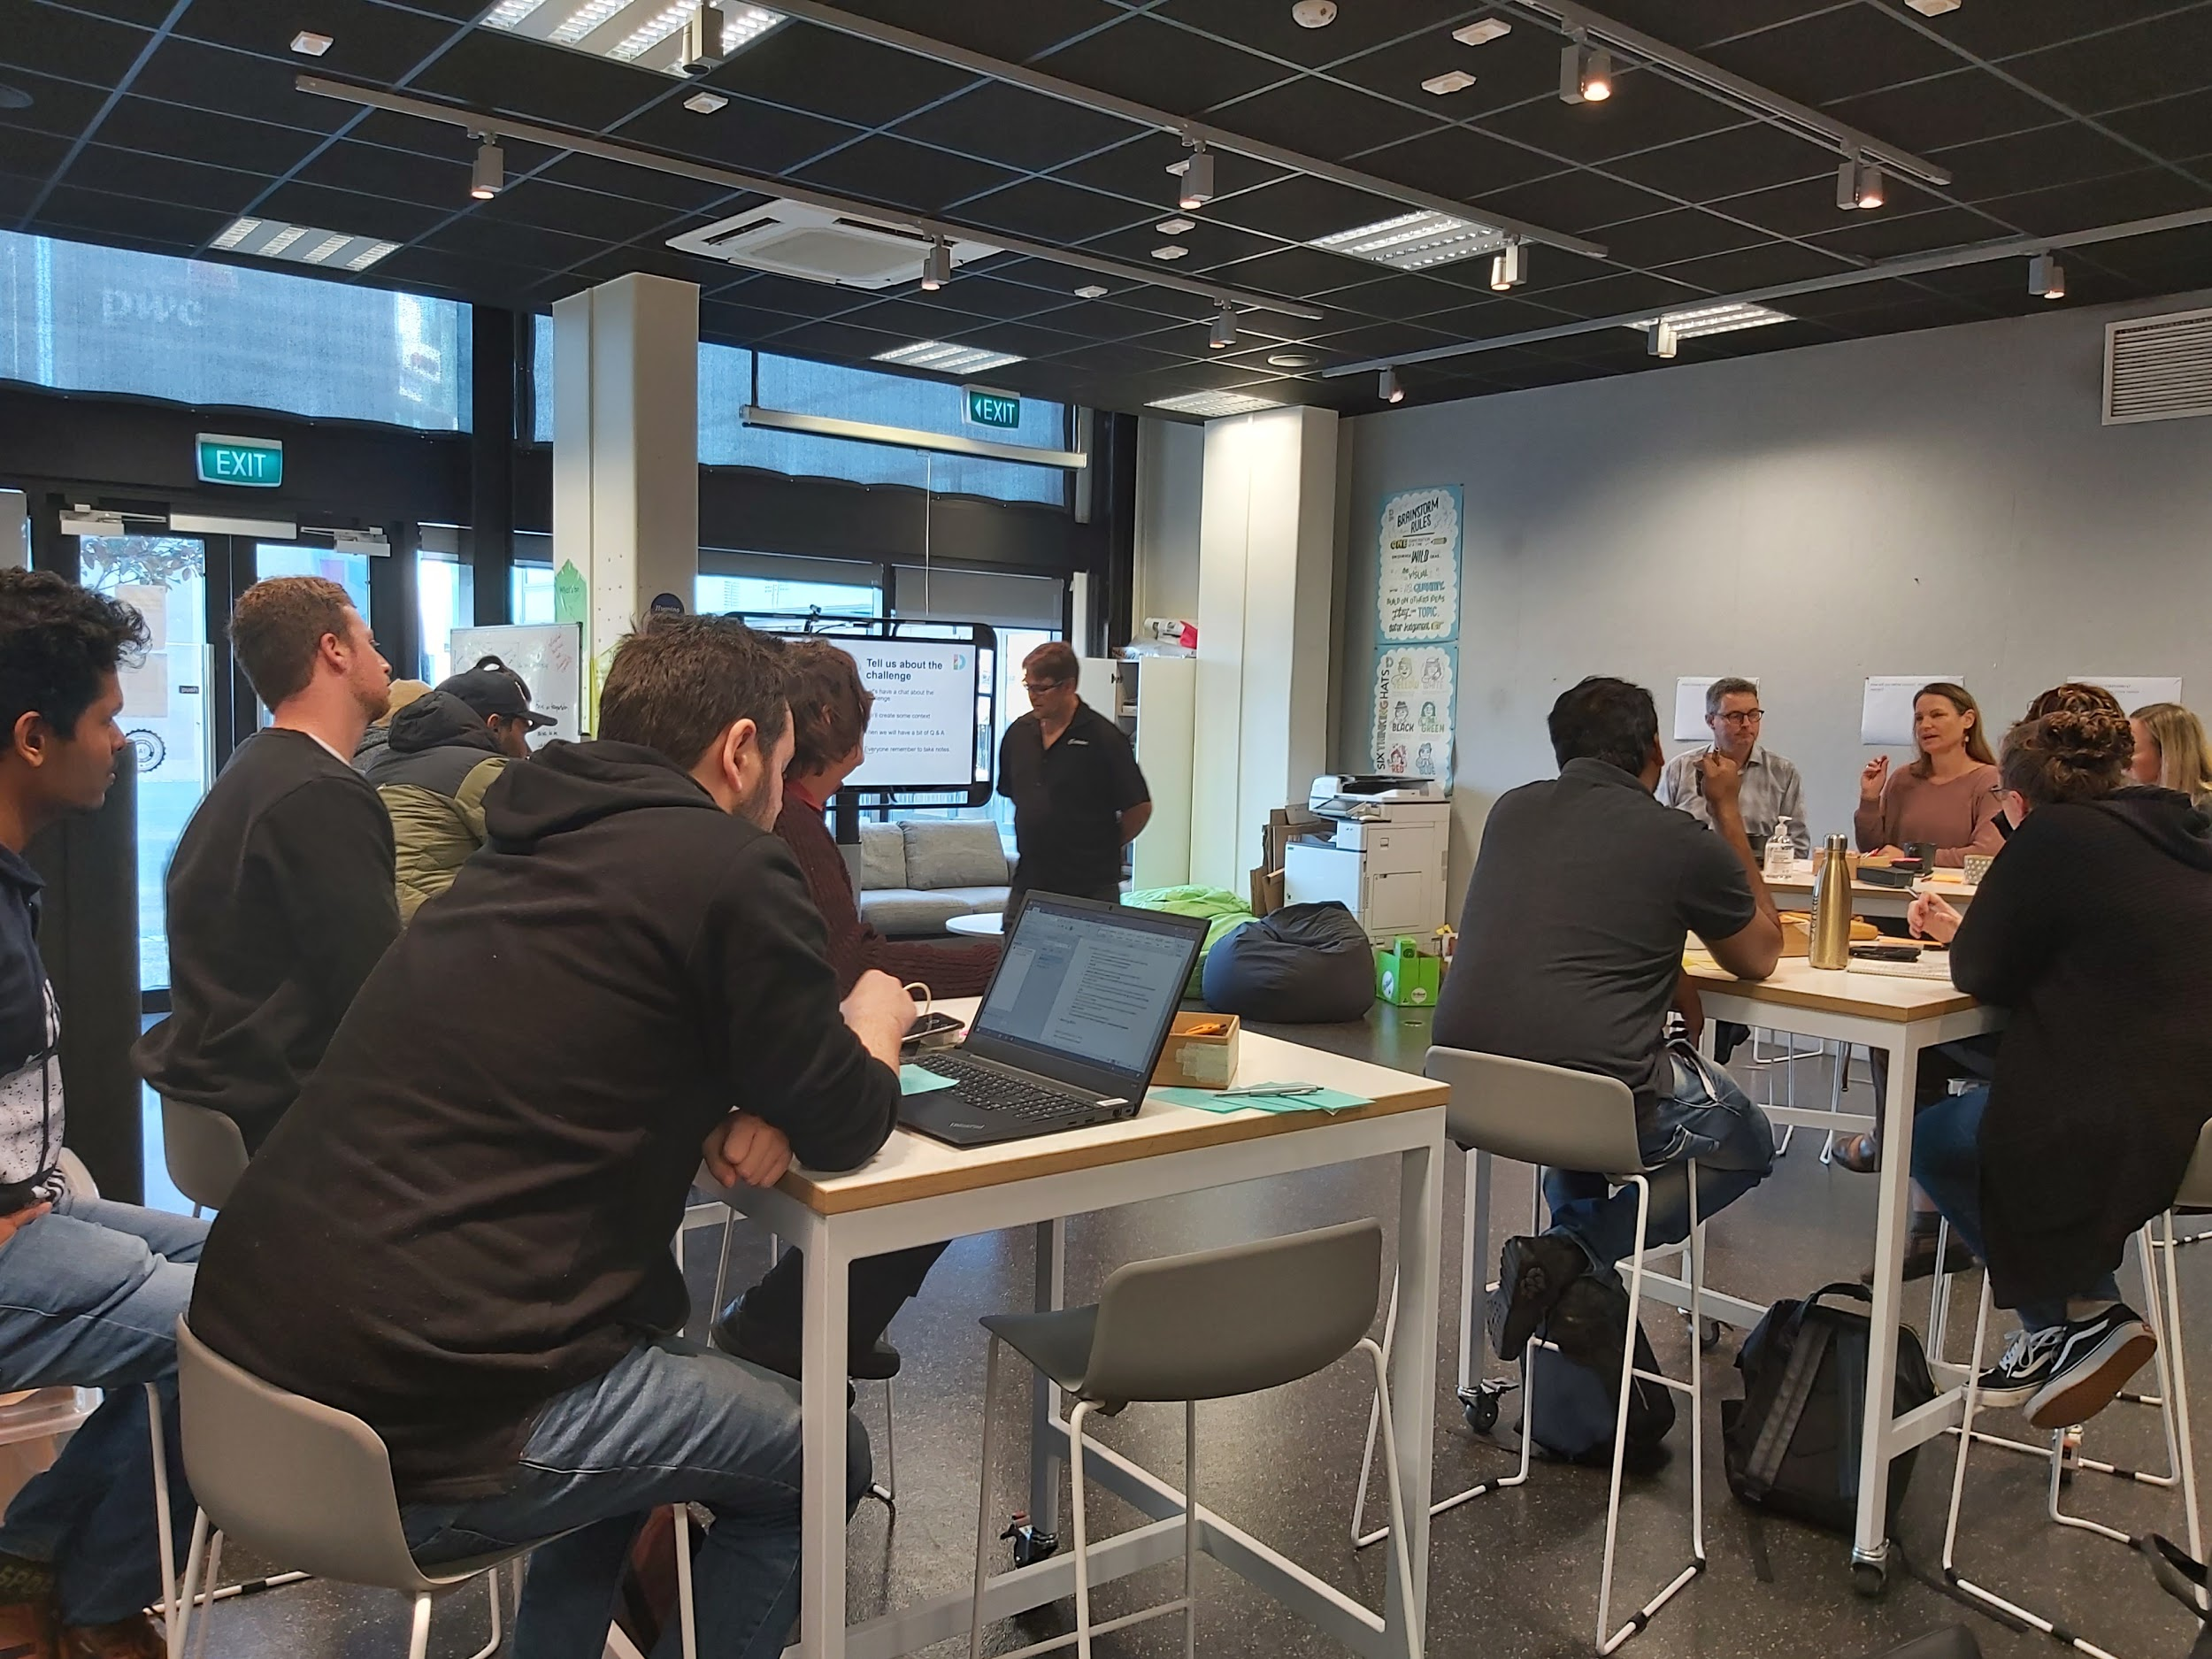

**Key Findings**

What we discovered was quite interesting, the data received was varied and gave us a good perspective of what people thought about the Hamilton CBD. One important thing we discovered was that a lot of people in general didn’t really know what exactly was going on in the CBD and assumed the same things. Parking issues were a very common answer from the members of the public and friends however this is another example of bad assumptions. From our interviews with employees of Center Place, most workers only ever come into the city to work, run their errands and go straight home. One employee even described her experiences in the CBD as “transactional”.

The general visual look of Hamilton was thought to be quite dated. While the new Victoria on the River area looks modern, the rest of the CBD is old and dirty as well as not very appealing to the eye. From the perspectives of the Hamilton Central Business Association, their main issue was that people just simply had no idea how great the CBD really is and find it vastly difficult to find out what is going on in town. Many people from the under 30 age bracket found that there wasn’t enough going in the CBD that suited their budgets, this is an issue as half of the population of Hamilton is under 30. (About Hamilton, n.d.)

# Affinity Map

With massive amounts of data collected through interviews and observations, requires a process of working out what to do with them all. To help with this, affinity mapping is used to help with this.

Affinity mapping is a great way of being able to make sense of all the information gathered when there’s lots of mixed data (Dam & Siang, 2020).

With the information the group went through all the information gathered from the different interviews carried out from businesses, public and even family and friends and wrote down key points from those interviews as well from observations we did in the city. Each point going on to a separate post it note.

Different coloured post it notes are used to identify the source of the information. This process continued until all the points of significance have been put on a separate post it note for each point as partly seen in the diagram below.

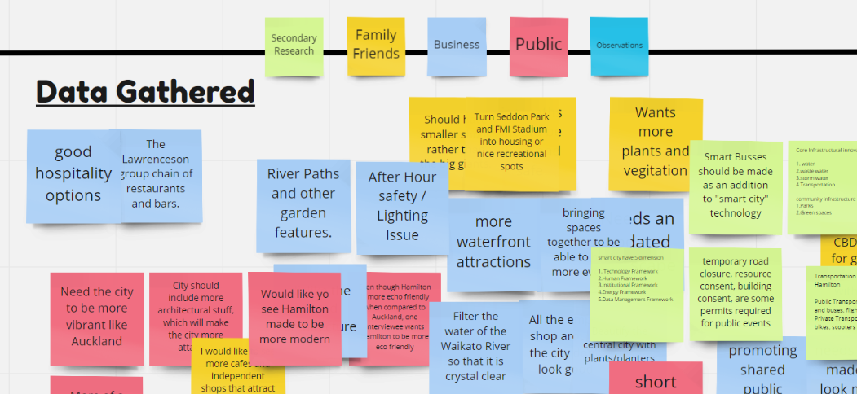

Figure 1: Creation of data by source (partially shown)

Next step was clustering the information to find common themes within. To begin with, the notes were grouped into categories. This process helped the team to understand the areas of the CBD that were talked about by those that were interviewed and was also where the team began to take in what was being said and in turn raising an awareness of the possible directions that could be headed in.

# 

### *Figure 2: Categories of Data (partially shown)*

# 

As can be seen from the above diagram those areas were in security, parking, personal experiences and so on. From there it went a bit deeper to find related information between the categories and which a certain issue was found between the categories. This is the second part of the clustering process.

# 

# 

# Redefinition

## Key Insights and How Might We Question

The group have gone through observations around the CBD, done secondary research on specified topics, done interviews with the Central Business Association people, general public, friends and relatives. We have got lot of points from them, which we have categorised based on their relevance and then we have clustered it on the basis of the important insights that we come across. Insights that we have gathered is listed below.s

### Signage improvements are needed to better direct traffic flow

Clusters

* Hard to find information to where to park
* Save time and effort if signs have been properly installed
* Easy to navigate if proper signage is installed
* Easy to find way around with appropriate signage
* Chances of get lost the way due to the lack of proper signage
* No clear signage to aid public where proper places are

Signage problem for the people around the CBD is a main problem that we come across when interviewed people. The general problem that we found is people find it very difficult to find parking spaces due to the lack of proper signage, it is easy to get lost if we don’t know the proper address of the place where we have parked out car, rush hour congestion which make it really difficult for parking as well as the visibility of the signage reduces due to this. If the signage is made proper people suggest it will be better to navigate and easy to find the way as well.

HMW Questions

* How might we improve signage of Hamilton in such a way to reduce effort and save time?
* How might we improve our media perception both physical and digital?

### Visual infrastructure improvements are needed to raise CBD perception

Clusters

* Need of city to be more vibrant and pleasant
* City should include more architectural stuff which will make the city more attractive
* City should be more clean and safe
* More waterfront attractions and greenery
* More murals, paintings and sculptures

The main thing in this insight is that most of the people find CBD not that vibrant as some of the cities in New Zealand such as Auckland and Wellington. Some say that the city should include more infrastructural and architectural implementations, which will make the city more vibrant and beautiful. Others are too keen for lot of greenery within the city and want the city to be much more clean and pleasant. People want the architecture of the city to be updated and thereby make the city more aesthetically attractive.

HMW Questions

* How might we implement visual infrastructure that would improve the visual representation of the CBD?
* How might we implement regulations to keep front facing business clean?

### Extra security is added to the volatile areas

Clusters

* After hour safety and lighting issue
* Violence centred around the Hamilton Depot
* CCTV camera should be implemented in important locations in Hamilton
* No night lighting at garden place

There is a need for extra safety in the CBD because it is a common issue of robbing cars, bicycle and other stuff around the CBD. People suggest to implement more lighting and security camera around the CBD, which will reduce the chances of burglary and other criminal activities also. No proper lighting in the garden place and violence centred around Hamilton depot is also an issue.

**HMW Questions**

* How might we implement different technology to improve the safety within the CBD?
* How would we implement added security in order to improve the public perception of safety within the CBD?

### Infrastructural improvements are required to either minimize vehicle traffic flow or increase parking availability

Clusters

* Not enough parking spaces in the CBD
* Malls feel to be too crowded and congested
* Rush hour congestion is a main problem during these days
* No enough staff parking spaces

More parking slots should be made within the CBD, because in rush hours no spaces will be available at all and people hesitate to come to CBD at that time. People use to shop from their nearest places other than CBD due to this reason.

**HMW Questions**

* How might we improve parking infrastructure in order to reduce traffic build up and increase parking availability?
* How might we direct traffic around the CBD to reduce congestion?

### Enhancing activities and entertainment in the CBD

***Clusters***

* Thera are not enough family oriented activities in the CBD
* Events happening in the CBD is not properly advertised
* Should include more musical events in the city, which attract people
* Not enough enjoyable activities
* Needs more events and outdoor activities
* More live bands in popular areas would be nice

People tell that there are not enough activities either for family or youth being done in the CBD and the activities that are being done is not properly advertised. People needs more festivals, entertainment and activities that are related to music etc. Since half the population in Hamilton is under 30 which is a population which is less earning, so more activities and events have to be conducted for them in subsidized manner.

**HMW Questions**

* How might we incentivize business to conduct events in the CBD?
* How might we create additional events or activities that would give people incentives to visit the CBD?

### Unaffordable/Expensive

***Clusters***

* Cost of Parking
* CBD is expensive for shopping purposes
* Shops expensive from Kmart and Warehouse
* Age group between 20 to 30 around CBD is more than 50%

People are finding CBD to be expensive in case of parking, shopping, food etc. According to the survey have of the resident under Hamilton is under 30, so the people in this age group will be about to begin their actual earning. So, these age group might think CBD to be expensive as well as the low income earning group.

**HMW Questions**

* How might we alter the student perspective of the CBD in regards of cost?
* How might we alter the CBD to cater towards people of lower income brackets?

### Business Open/Close Hours

***Clusters***

* Shops are closing around 5 or 6 and opening late
* Extend business opening and closing hours
* No night life other than week ends

Shops are opening late and closing earlier which prevents the people from shopping after their work hours. Most of them tell that Auckland is quite good because shops will be only closing at 10. People who are working have to wait until the weekend to shop something, but most of the shops will be close in the weekend, which we have to take into consideration.

**HMW Questions**

* How might we reduce and regulate the number of undesirables within the CBD?
* How might we alter business hours to improve the liveliness of the CBD?

### Loitering and Harassment

Clusters

* Homeless and begging issues need to be solved
* Too many beggars on the street
* Annoying surveyors

There is lot of homeless people and beggars around the CBD which some people will affect the business.

**HMW Questions**

* How might we reduce the rate of homelessness in the CBD?
* How might we create ways for the people to move around the city more instead of loitering around?

# Timeline for second term

From here the team will be commencing and completing work in the last three stages of the Design Thinking Process. These being Ideation, Prototyping and lastly Testing.

**Ideation:**

This stage is where the team is ready to generate ideas based on the knowledge that has been formulated from the first two stages of the design thinking process. It is the time to be able to formulate ideas from the public's perspective as well as the client’s perspective to even wacky ones to address the wicked problem.

**Prototyping**:

This is where the creativity of a product or solution begins to take place. A time to experiment with the team producing some inexpensive, scaled-down versions of a product that will eventually become the finished product. It can be as simple as doing paper prototyping ie for a app using sketches on paper to represent the different screens shown.

**Testing:**

This is the stage where a solution is tested to meet current design specifications in solving the wicked problem. This process can be iterative and the results from each test are used to refine the product so that it is pleasing to the user of that product. It may be that a solution is not workable, in which case the list of potential solutions need to be revisited to find an alternative that can solve the wicked problem. User feedback plays an important part in this process.

# References

Dam, R. F., & Siang, T. Y. (2020, August). Affinity Diagrams – Learn How to Cluster and Bundle Ideas and Facts. Retrieved from Interaction Design Foundation: https://www.interaction-design.org/literature/article/affinity-diagrams-learn-how-to-cluster-and-bundle-ideas-and-facts

# Appendices